**Will Someone Really Hit .400 this year?**

Probably not.

There is chatter about how this year’s stats are going to look crazy when taken out of context due to the shortened season. While this is true, I think the size of the effect people claim is overstated. I have heard more than once that this year somebody is going to it over 400 this year. I think it is likely that someone ill hit .350 or .360, but .400 is quite unlikely.

To show this, I simulated 1000 shortened seasons where a guy who hits .320 takes 270 at bats over 60 games. What I did was in each at-bat assume he gets a hit with probability 32% then simulated all these at-bats and computed what his season average was.

In the plot below, between the red lines accounts for the middle 95% of seasons and between the green lines the middle 99% of seasons. Essentially you should think that a true .320 hitter as a 95% chance of having his season long average falling between the red lines. So, there is less than a 1% chance that a .320 hitter will break .400 for the season.

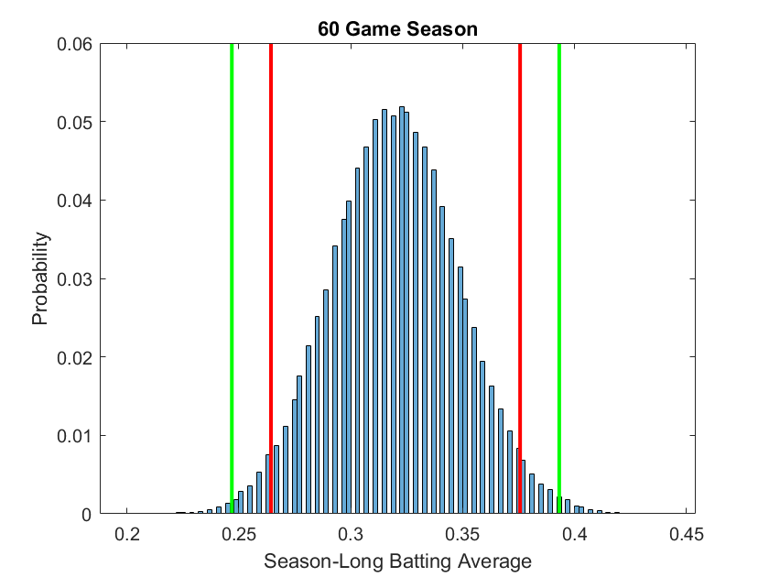

Almost everything suggests the career .320 hitter is going to bat between .250 and .390 for the shortened season. Compare this to same experiment for a 162 game season.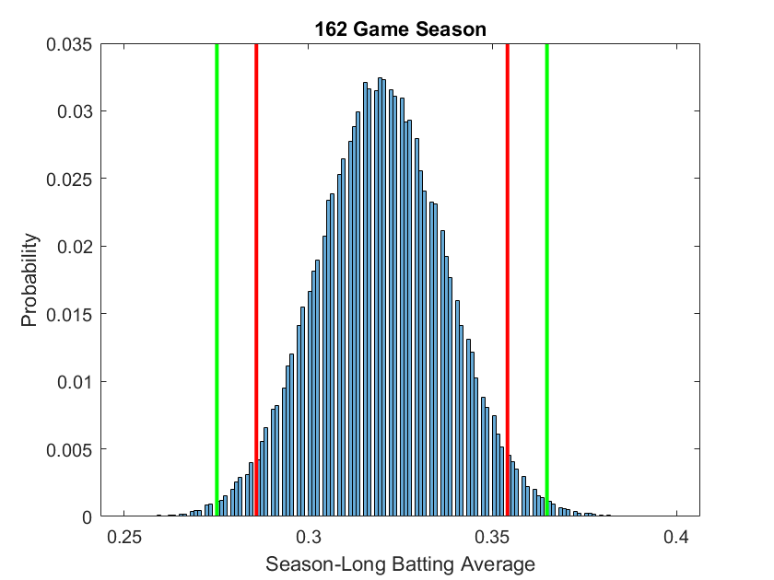

Now, the guy is almost guaranteed to be between, say, .280 and .360 for the full length season. Notice that the shortened season allows for a much wider range of outcomes, but batting .400 is still quite a ways off. Look for a full length article discussing this in more detail in the next few days.